Board member recruitment pack

3-4 | Letter from the Group Chair and Group Chief
 | Executive
5 | How to apply and the selection process
6 | About The Barnet Group
9 | Our Core Values
10 | The Barnet Group Board
10 | The role of the Board
11 | The general responsibilities of Board members
12 | Role description and person specification
13 | Principal terms and conditions

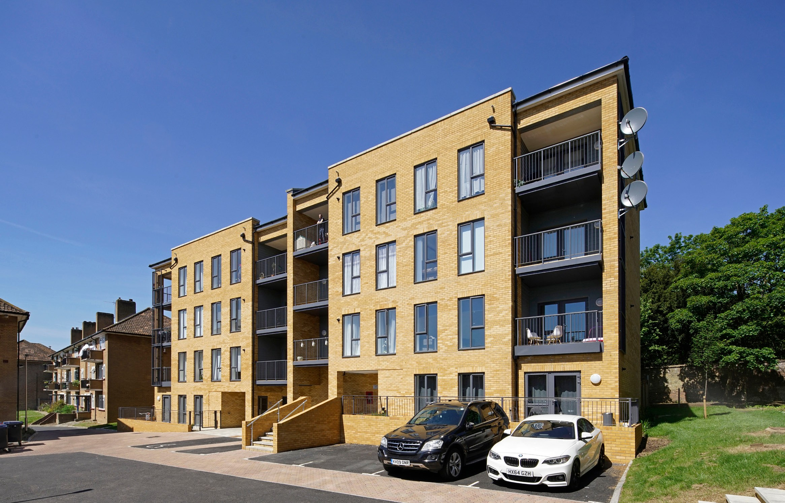

The Barnet Group – The Barnet Group Board Member Recruitment

Welcome to The Barnet Group (TBG) and thank you for your interest in the position of Board Member.

This is an exhilarating time to be joining TBG. As one of the first local authority trading companies to be created, we have blazed a trail in terms of growth and innovation in the housing sector and beyond, and are ambitious for more. We have grown from 250 employees to over 800, and now manage more than 15,000 properties in addition to delivering the Council’s homelessness service and housing options. We also have Your Choice Barnet, providing specialist care and support to adults with a range of mental and physical disabilities, as a subsidiary of TBG. We have a turnover of around £80 million and have completed just under 500 new build homes with over 370 more on site and over 800 more in early stages of pre-construction development. Alongside this, we have acquired over 500 homes to meet homelessness need with a further 130 still to be purchased.

We have a supportive culture and an excellent relationship with the Council. The future of TBG is secure and we are in our 7th year of the ten-year management agreement for our Arms Length Management Organisation (ALMO), Barnet Homes.

I do hope that after reading this pack you will be inspired by our energy, ambition and hunger for growth as well as the importance we place on our people, and be inspired to join us.

Yours sincerely, Eamon McGoldrick

Chair of The Barnet Group

What a time it has been since The Barnet Group (TBG) was created in 2012. The Group has seen significant growth and long-term management agreements for both Barnet Homes and Your Choice, meaning that the future is both secure and exciting.

TBG is a local authority trading company established in 2012. We are owned by Barnet Council, and are the parent company to Barnet Homes (our ALMO), Opendoor Homes (our RP), Your Choice Barnet (care and support provider) and Bumblebee (a private lettings agency).

We are seeking a new board member to contribute to the leadership and strategy of TBG during this exciting time. Ideally, we would like to find an applicant with a specialist background in housing management, repairs and asset management. It will also be beneficial if applicants have an understanding of the Barnet locality. TBG encourages applications from people from diverse backgrounds and origins. The remuneration for a board member of TBG Board will be £5,000 a year, and new members will be expected to make time available for induction during July and August, with a view to taking up the role from September 2023 onwards.

We would like to improve the diversity of our board to better reflect our customers, and the rich diversity of the borough of Barnet. We welcome applications from all backgrounds, but would particularly encourage candidates whose views are currently under-represented on our board to consider applying: people from Black, Asian and minority ethnic backgrounds, younger candidates, and people with a disability. First time Non-Executive Directors are welcome to apply and support will be provided.

This recruitment pack, along with our latest published Business Plan, gives you more information about the Group, the board and the role of board members and is intended to assist you in applying for the role.

We look forward to hearing from you and thank you for your interest in joining our board.

Yours sincerely,
Tim Mulvenna Chief Executive

How to apply

To apply, please:

Contact chloe.bryant@barnethomes.org to register your interest. Links to a recruitment pack, a Board Member role profile, and The Barnet Group Strategic Plan are available within the advert

write a supporting statement (maximum 2 sides of A4) – link provided within the advert

provide an up to date CV

The closing date for final applications is 12pm on Monday 26th June 2023 so please register your interest with enough time to apply fully.

Selection process

Face to face interviews for shortlisted applicants will be held at The Barnet Group head office in Colindale, 2 Bristol Avenue, NW9 4EW. Interviews will be held on Monday 10th July and will commence at 10am, please save this date.

Applications will be reviewed by the Executive Team and shortlisted applicants notified by 30th June.

Shortlisted applicants will be invited to a two stage interview. The interview panel will consist of:

First Interview
Penny Farrar - Chair of the Governance and Remuneration Committee
Richards Stevens - Incoming Chair of the Audit and Risk Committee
June Riley – Senior Independent Director

Second Interview
Eamon McGoldrick - Chair of the Board
Tim Mulvenna - CEO

All unsuccessful candidates, at any point in the process, will be informed and offered feedback.

About The Barnet Group
The Barnet Group is a local authority trading company established in 2012. We are owned by Barnet Council. The group is the parent company to Barnet Homes, Your Choice Barnet, Opendoor Homes, Bumblebee Lettings and TBG Flex.

We are active partners with groups across the community to deliver training and employment support, community development and youth engagement services.

We combine a public sector ethos with a private sector commercial focus.

Barnet Homes was created in 2004 to manage housing on behalf of London Borough of Barnet and to deliver a £185m decent homes refurbishment programme which is now complete. Of our c12,000 properties, about a quarter are leaseholds most of whom have bought their homes on the open market.

Barnet Homes has around 800 staff and operates out of three main offices across the borough to ensure a strong local focus to our service delivery. We also manage about 2,500 units of temporary accommodation. We provide homelessness services, tenancy and leasehold management, income collection, repairs management, temporary housing, major projects, estate services, new build and resident involvement.

With around 300 staff, Your Choice Barnet was created in 2012 as a specialist social care organisation offering support for more than 350 service users with physical and learning disabilities from six centres, four supported living schemes and across the community.

We now also manage a new state of the art extra care scheme at Ansell Court built by Barnet Homes and three care homes also recently transferred into Your Choice Barnet. We encourage people to make use of personal budgets, exercise choice through individual plans and take real control over their own lives.
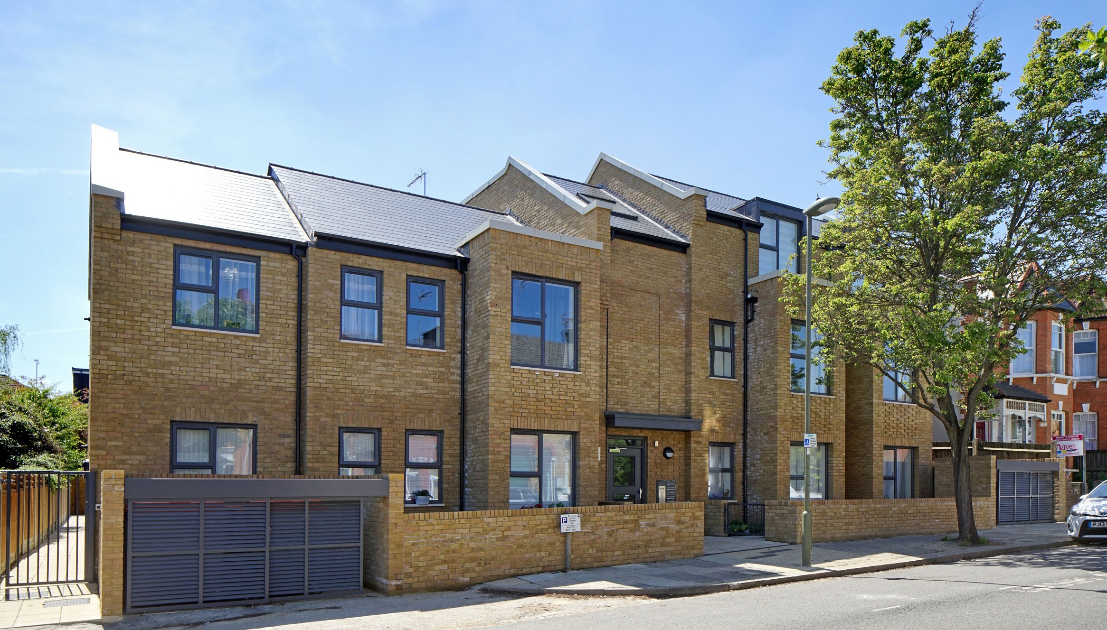

We created a subsidiary to Barnet Homes, Opendoor Homes, a Registered Provider with the Regulator of Social Housing, in 2017 which will help support the Group’s ambitions for growth whilst providing much-needed affordable rented housing within the borough. Opendoor Homes will deliver a construction programme of circa £81 million due to complete in 2022 and is currently exploring a number of opportunities to build, transfer or acquire a further 1500 homes by 2025 whilst becoming the Council’s preferred development partner.

In 2015, TBG Flex was created to employ and supply new employees within the Group, offering more flexible terms and conditions of employment.

Our most recent subsidiary, Bumblebee Lettings, is a private lettings company which will generate surpluses for the benefit of the Group as a whole.

Our company structure
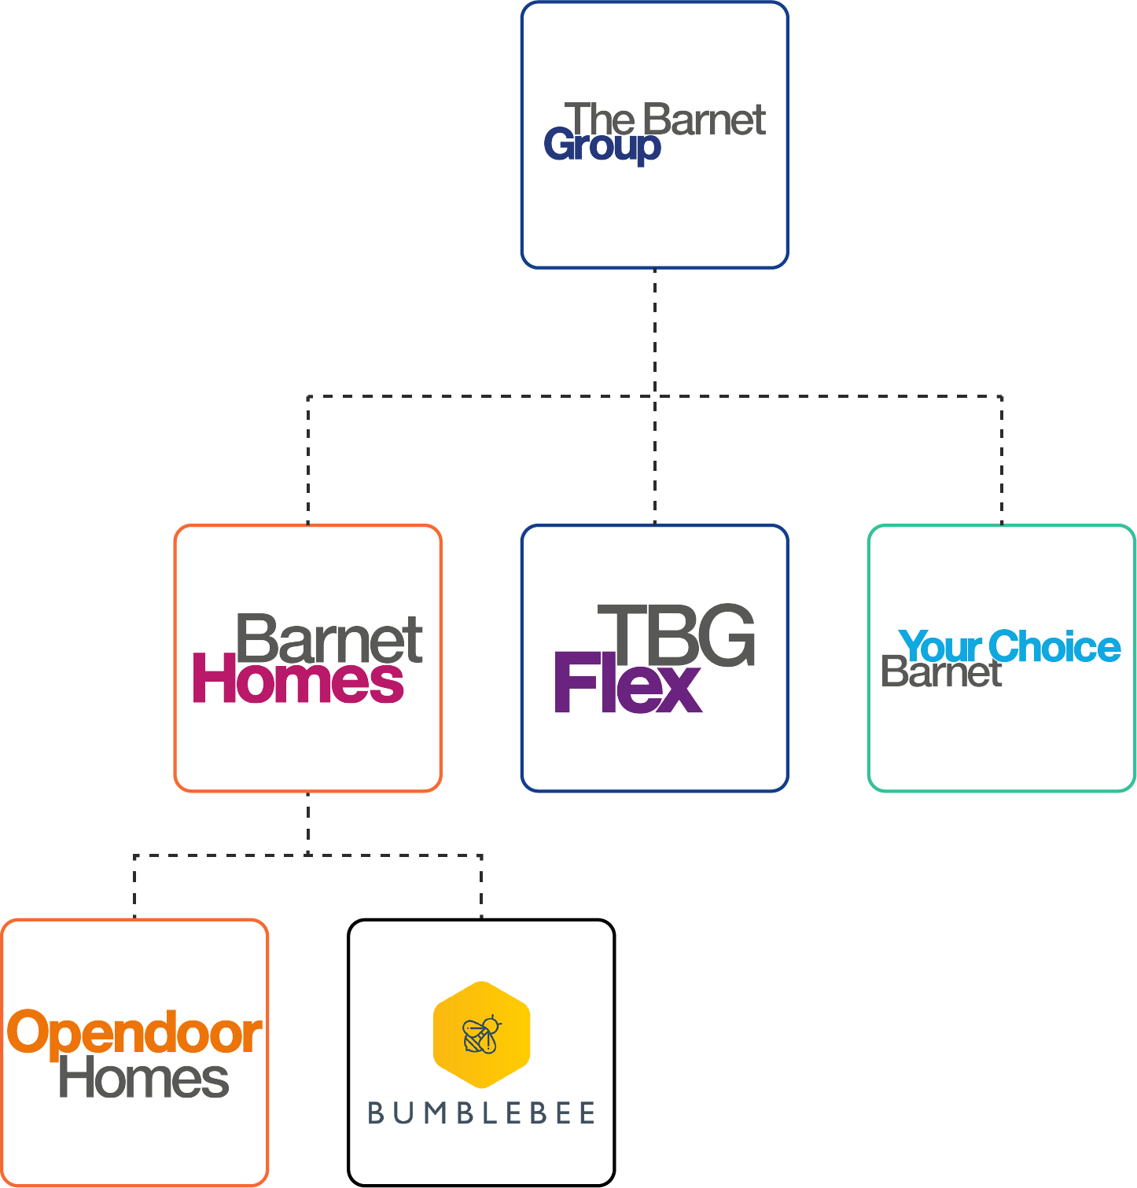
The creation of The Barnet Group was an innovative venture to establish a new relationship with citizens in the borough whilst providing a more flexible and efficient service.

We have built on the strengths of Barnet Homes, which include strong customer involvement and engagement, and a track record of combining business efficiency with rising resident satisfaction.

The Barnet Group has its own board which operates as a common board for all entities within the Group apart from Opendoor Homes and Bumblebee Lettings, which have their own boards. It is supported by a group Audit and Risk Committee and a group Governance and Remuneration Committee.

Our core values

Our mission
To make a real difference to every customer.

Our vision
For customers to be our biggest advocates.

Our values
Show respect – Treat other people as you wish to be treated yourself.

Find solutions – Think outside the box, and be innovative.

Make a difference – Go the extra mile to show your customers you really care.

Be people centred – Treat everyone you meet as an individual, and remember, one size does not fit all.

The Barnet Group Board
The Barnet Group Board meets at least quarterly.

Board members can serve more than one term, which is usually three years, subject to satisfactory performance. The Chair carries out an annual individual appraisal of The Barnet Group Board members, and a retained external governance consultant undertakes an annual review of collective board effectiveness.

The role of the board
The board operates as a common board and has responsibility for the governance of the whole of The Barnet Group.

The board’s role is to be accountable to the London Borough of Barnet for the services and performance of The Barnet Group. This includes the following responsibilities:

- set the vision – where the organisation is going and what its goals are
- set the objectives – set out the key objectives which need to be met in order to realise its vision
- define the strategy – the details of how the organisation will deliver the objectives
- define the core values – how the organisation should act and behave.

Executives are responsible for implementing the strategy and report to the board. Board members should not get involved in day to day management issues but should remain strategic.

The duties and functions of the board include:

- ensuring compliance with regulatory standards
- the strategic direction of the planning, negotiation, funding and implementation of the development programme
- defining and ensuring compliance with the values and objectives of the organisation
- agreeing a business plan with the London Borough of Barnet
- defining and ensuring compliance with the business plan through the agreement of: - - policies and action plans
- budgets
- a framework of delegation and system control.
- monitoring the organisation’s performance in relation to these plans, budgets, controls and decisions
- approving each year’s budget and accounts prior to publication
- making decisions on all matters that might create significant financial or other risk to the organisation, or which raise material issues of principle
- satisfying itself that the organisation’s affairs are conducted lawfully and ethically, within the terms of its constitution and within generally accepted standards of performance and propriety.

The general responsibilities of board members
All board members take collective responsibility for decisions made by the board.

Each member should act only in the interests of the organisation and not on behalf of any constituency or interest group.

Board members must at all times comply with the duties imposed by the Companies Act 2006, including:

- the duty to act within the powers of the company
- the duty to exercise independent judgement
- the duty to promote the success of the company
- the duty to exercise reasonable skill, care and diligence
- any other directors’ duties set out in the Act as updated or amended from time to time.

Board members are also expected to:

- comply with the company’s policies, procedures and standing orders as set and amended from time to time by the board
- act in accordance with the constitution
- uphold and promote the core policies, purpose, values and objectives of the company (including its commitment to equal opportunities)
- contribute to and share responsibility for decisions of the board and/or any committee of which they are from time to time a member
- read board and/or committee papers (as applicable) before meetings
- represent the company when requested
- act in the best interest of the company at all times.

Involvement required
All board members are given a copy of the Code of Conduct and service agreement specifying their obligations, and must sign a copy to indicate acceptance.

Being a board member requires:

- participation in an induction programme to become familiar with the business and workings of the board
- regular attendance at and preparation for board and potentially some committee meetings if required subject to skill sets (we have a target of 90% attendance)
- occasional supplementary virtual boards for urgent matters such as scheme approvals
- attendance at a board ‘away day’ twice per year
- attendance at significant company events
- participation in appraisals and attendance at development events (based on board and individual needs)
- ongoing individual and collective training, as required, and personal development.

We estimate that the time commitment needed is approximately twelve days a year. Availability for meetings starting at 4pm, and occasionally at short notice, is required. The meetings are a mixture of virtual and face to face. The business uses Convene as our Board platform and full training will be provided.

Role description and Person Specification
You should be able to demonstrate and provide evidence of the criteria listed under the person specification within your written application. These will be tested further at the interview stage, along with understanding and fit against the role description.

Role description
Board member responsibilities include:
- Leadership –accountability for the direction and control of the Group and collective responsibility for Board decisions
- Strategy –set objectives, strategic aims and outcomes for the Group, drive development of the Business Plan, review and evaluate the operating environment, and monitor delivery of objectives
- Financial control – ensure financial viability of the Group through effective business planning and budgeting
- Performance monitoring – review and monitor performance of the Group against objectives
- Risk – ensure a framework of prudent and effective controls which enable risk identification, assessment and management is in place
- People – ensure human resources and policies are in place to enable the Group to meet its objectives
- Legal and regulatory – ensure the Group complies with its governing documentation, all legal and statutory obligations, all regulatory requirements and any contractual obligations
- Governance – participate in individual and collective appraisals, promote openness, transparency and accountability in dealings with stakeholders, declare relevant interests and establish and oversee delegations and internal controls.
- Representation – act as an ambassador for the Group both internally and externally
- Self- management – be pro-active in staying well informed, prepare for and contribute effectively to meetings, participate in induction and other training programmes, respect colleagues, uphold the Code of Conduct and maintain highest standards of probity, respect

Person specification
Board members should have a diverse range of skills, competencies and experience, including:
- Work as an effective team to take strategic decisions for social outcomes.
- Direct knowledge of the needs and aspirations of the communities and people served.
- General business, financial and management skills.
- Have a specialist background in housing management, repairs and asset management
- Show an understanding or the ability to develop, an understanding of the principles of effective governance.
- Demonstrate an understanding of, or willingness to undertake training in equal opportunities, both in service delivery and provision.
- Prepared to participate in regular board development activities.

13

2023/24 Group Board & Committee meeting dates
G&R Committee - 5th September – 4pm – virtual
A&R Committee – 7th September – 4pm – virtual
Group Board - 21st September – 4pm – face to face
G&R Committee – 28th November – 4pm – virtual
A&R Committee – 30th November – 4pm – virtual
Group Board - 14th December – 4pm – face to face
March 2024 - TBC
June 2024 - TBC

Principal terms and conditions
- Position: Board Member of The Barnet Group Board

- Remuneration: £5,000 per annum paid monthly in arrears

- Commitment level: approximately twelve days per annum

- Location: 2, Bristol Avenue, London, NW9 4EW or virtual if required

- Expenses
Board members can claim reasonable business expenses, such as train fare to and from board meetings and carer’s allowance, if appropriate. All reasonable help for adaptations for disabilities or special needs will also be provided.

- Other
Board Service Contract: All board members are required to enter into a service agreement with The Barnet Group which sets out the expectations required of the role.

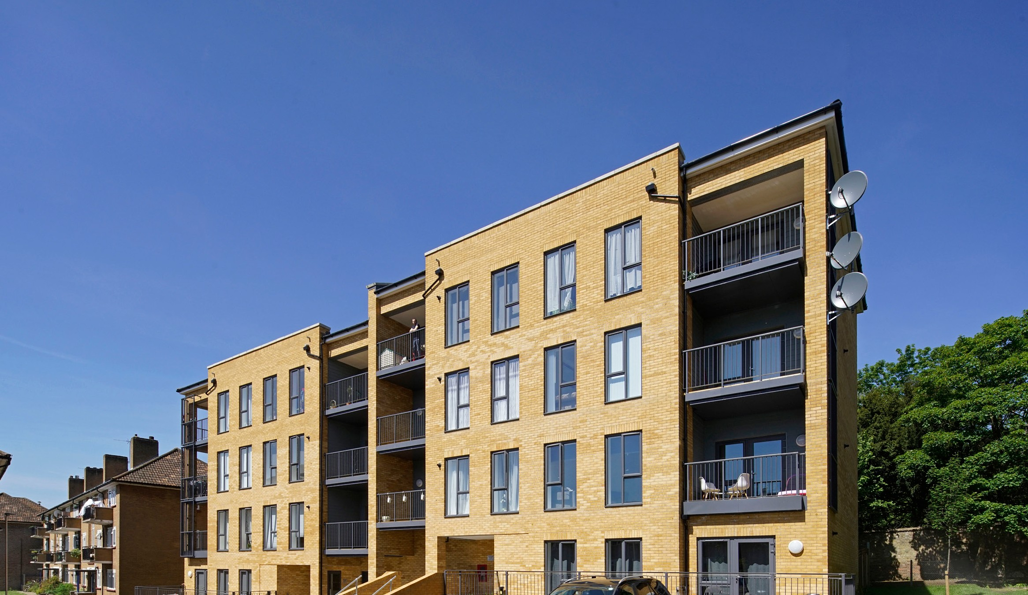
Code of conduct and declaration of criminal offences: All board members are required to sign the Directors’ Code of Conduct and declaration. They are also required to declare conflicts of interests.

2 Bristol Avenue, Colindale, London NW9 4EW thebarnetgroup.org
info@thebarnetgroup.org @thebarnetgroup
TBG0008

